Beverage Creation – Classroom Activity
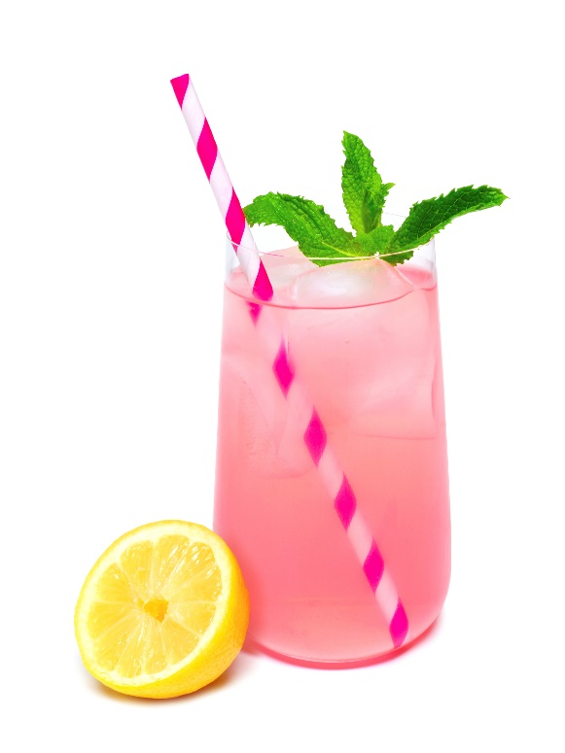
Introduction
Food product development is a cool job that allows you to create products for the grocery store. There are many skills a product developer (in any industry) needs to possess, but organization, creativity and scientific knowledge are three of the most important! On average, it takes about 1-2 years to develop a new food item or new flavor lines for an existing brand. 15,000 new products are developed each year and approximately 90% of the new products fail. Wow!
Products can fail for a lot of different reasons, but taste is something that can not be compromised. Let’s make 2 beverages and compare them!

Let’s Begin!
We are going to prepare 2 beverages, side by side, one with sugar; one sugar free.
You will need:
- 2 Rubbermaid Plastic (2 quart) bottles, with lids
- 1, gallon Spring water (needs to be Spring)
- 2 packets Kool-Aid Unsweetened soft drink mix (any flavor, 2 of the same flavor)
- 1 cup granulated table sugar
- 24 packets of any sugar substitute (HIT – High Intensity Sweetener) such as Truvia (green packet), Equal (blue packet), Sweet ‘N Low (pink packet) or Splenda (yellow packet).
- 2 tasting cups per student

Directions:
- Label each plastic bottle: one SUGAR, one SUGAR-FREE
- Fill each bottle to the 1-quart mark with SPRING WATER.
- Add one KOOL-AID packet to each container. Tightly close each container and shake to completely dissolve.
- Add 1 cup of sugar (48 teaspoons) to the SUGAR beverage container
- Add 24 high intensity sweetener packets to the SUGAR-FREE container. (You can read more each high intensity packet is equivalent to 2 tsp of sugar)
TALKING POINT *** Notice the difference in liquid level in the 2 containers. Sugar contributes more volume, so the sugar beverage will require the addition of LESS water to reach the 2-quart mark.
- Tightly close the containers and shake to dissolve the sweeteners.
- Add additional water to the 2-quart mark on each container.
TALKING POINT: Do not add 2-quarts of water, if that is done the resulting product would make 2.15 quarts if using sugar as the sweetener, and the resulting taste will be more dilute than the ideal package recipe.
- Shake well.
TALKING POINT: Notice that there is still water left in the gallon jug of spring water even though we have made the equivalent of 1 gallon of Kool-Aid (2 qt + 2 qt = 1 gallon). Why? This is because sugar contributes to the volume of liquid.
- Pour each beverage into tasting cups.
- Have students compare the taste of each beverage.
- Discuss the samples, likes & dislikes.
- Compare the calories in each beverage choice. 1 cup of sugar contributes 773 calories in the 2 quarts of beverage while the high intensity sweetener contributes 0 calories. In a typical 8 ounce serving, the sugar-based beverage has 97 calories, while the sugar free has zero calories.

Beverage Creation – Considerations

Water:
- For a comparison, all samples should be made with water from the same source. When in doubt, use spring water for preparation.
- Some municipal water supplies are inconsistent in chlorine levels during the day; some water sources have musty, sulphury, or other off flavors at various times.
- For accurate comparison of the products, the added ingredient, in this case water, should be consistent from sample to sample.
- Spring water is the most consistent form. Distilled water should be avoided.
The main ingredient in a beverage is typically WATER.
- Food scientists generally use SPRING WATER in their work since it is consistently good tasting and the minerals in it enhance the flavor of the end- product (the product sold on the market).
- Tap water can be inconsistent depending on the water source and how long it has been in the pipes.
- Distilled water which has the minerals removed, has a flat taste that is imparted to the beverage.
- **As a side classroom activity, students could do a taste comparison of SPRING, TAP, and DISTILLED WATERS to experience the differences themselves.**
Sweeteners:
- Most of the high intensity sweeteners are about 200 times the sweetness of sugar by weight. These include green packet Truvia with Stevia natural sweetener, blue packet Equal with Aspartame, and pink packet Sweet'N Low with Saccharin.
- The yellow packet Splenda with Sucralose is about 600 times the sweetness of sugar.
- For classroom use, it is easiest to use commercially available sweetener packets rather than the pure ingredients.
- Each sweetener packet is equivalent to about 2 teaspoons of sugar.
TALKING POINT: How is 1 pkt of sweetener = 2 tsp sugar? That does not make sense, does it? The artificial sweetener packets are mostly made up of ‘bulking agents’ (Maltodextrin & Dextrose). 95% of the Splenda packet is the ‘bulking agent’ and 5% is Sucralose, the artificial sweetener.
- For 1 cup of sugar (about 48 teaspoons) in a recipe, an equivalent of 24 sweetener packets would be used if making a sugar free product.
- Or you can try to make your own “Koolaid” mix (using an acid, flavor and color).

Suggestions for Serving
- All samples should be served in the same type of container.
  - Preferably clear or translucent rather than opaque so appearance (color, cloudiness, etc) is more noticeable.
  - 2-oz. or 3-oz. beverage cups are appropriate
- Samples should have been prepared at the same time and served at the same temperature.
  - Cover & chill both beverages, or serve both at room temperature.
  - Cold suppresses flavor.
  - Do not serve over ice. The ice will dilute the beverages and make the comparisons less valid.
- Tasting order:
  - Sugar based beverages should be tasted before sugar-free, which generally have a lingering sweet taste.
  - If tasting different flavors of beverages, More delicate flavors should be tasted first to avoid flavor carry-over. (For example, lemon before grape.)
Questions to extend learning
Creation of a beverage requires food scientists to make a myriad of decisions before beginning. Among them are: *there are no right or wrong answers, just things to think about.
- Who is the target audience - kids, active adults, seniors?
- What flavor and color should it be?
- Should it be unsweetened or sweetened?
- If sweet, should it be with sugar or one of the many high intensity sweeteners available?
- What is the price difference per beverage (sweetener vs artificial sweetener)?
- What if you do not like the taste of artificial sweeteners, but want a reduced calorie product? Think outside of the box! If you want a reduced sugar product, you can mix the two beverages and have a 50% reduction in calories.
- How could you make a beverage like this more upscale & premium? What could you add or do differently?
- If you make the product more premium, can it still be stored in the same area as Kool-Aid in the grocery store?
- Would you use the Kool-Aid name, as it’s a highly recognizable name?

