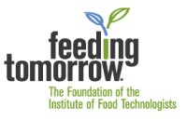
NAME OF GROUP
Educator Event

LOCATION, DATE, TIME
Calling all teachers!
Do you want to learn about the most exciting industry in the world? You & your students consume our products many times a day!
The food industry combines all disciplines: chemistry, biology, foods, English, engineering and math, cultural & government, design & marketing. Do you teach science or foods classes and want to reenergize some of your lessons?
Attend our Educator Event!
Come join us and meet with industry professionals, learn about the science behind food, see careers in action, connect with other area teachers interested in using food as a medium for teaching STEM concepts. You will walk away with so much knowledge and a newfound appreciation for the science behind food! Come spend the day with us to make industry & academic connections and have fun with engaging lessons and demonstrations to share with your students.
Sound interesting? RSVP here today! (INSERT INFORMATION ABOUT RSVP INSTRUCTIONS)

About Us
(INSERT GROUP DETAILS)

